**Energy, nutrients and digestion**

* Food and drinks provide energy and nutrients in different amounts, they have important functions in the body and people require different amounts during their life.
* Digestion involves different parts of the body, each having an important role.

**Micronutrients**

**Vitamins**

There are two groups of vitamins:

* fat-soluble vitamins, e.g. vitamins A and D.
* water-soluble vitamins, e.g. B vitamins (thiamin, riboflavin, niacin, folate, vitamin B12) and vitamin C.

**Minerals**

Minerals are inorganic substances required by the body in small amounts for a variety of different functions. Examples include: calcium, sodium and iron. Most micronutrients are mostly provided by the diet. An exception is vitamin D which can be synthesised by the action of sunlight on the skin.

**Energy from food**

* Energy intake is measured in joules (J) or kilojoules (kJ), but many people are more familiar with the term calories (kcal).
* Different macronutrients provide different amounts of energy.

**Nutrients**

There are two different types of nutrients:

* macronutrients;
* micronutrients.

There are three macronutrients that are essential for health:

* carbohydrate;
* protein;
* fat.

There are two types of micronutrients:

* vitamins;
* minerals.

**Energy**

Energy is essential for life, and is required to fuel many different body processes, growth and activities.

These include:

* keeping the heart beating;
* keeping the organs functioning;
* maintenance of body temperature;
* muscle contraction.

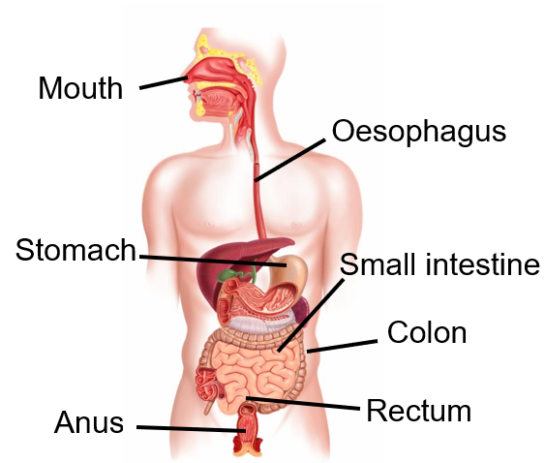

**Energy in**

**Energy out**

**Energy in > Energy out = Weight gain**

To find out more, go to: <https://bit.ly/31CBjke>

**Digestion**

The body requires energy from food and drink. Our bodies release the energy and nutrients from food.

The food passes down the Gastrointestinal tract (GI) tract as shown below.

**Energy balance**

To maintain body weight it is necessary to balance energy intake (from food and drink) with energy expenditure (from activity).

**Body Mass Index (BMI)** can be used to identify if an adult is a correct weight for height.

**BMI = weight (kg)**

**(height in m)2**

**Recommended BMI range (adults)**

Less than 18.5 Underweight  
**18.5 to 25 Desirable**  
25-30 Overweight  
30-35 Obese (Class I)  
35-40 Obese (Class II)  
Over 40 Morbidly obese

**Energy requirements** vary from person to person, depending on the Basal Metabolic Rate (BMR) and Physical Activity Level (PAL).

**Total energy expenditure =**

**BMR x PAL**

|  |  |
| --- | --- |
|  | Energy per 100g |
| Carbohydrate | 16kJ (3.75 kcals) |
| Protein | 17kJ (4 kcals) |
| Alcohol | 29kJ (7kcals) |
| Fat | 37kJ (9 kcals) |

**Key terms**

**Energy**: The power the body requires to stay alive and function.

**Digestion:** The process by which food is broken down in the digestive tract to release nutrients for absorption.

**Macronutrients:** Nutrients needed to provide energy and as the building blocks for growth and maintenance of the body.

**Micronutrients:** Nutrients which are needed in the diet in very small amounts.

**Tasks**

1. Create an infographic on either macronutrients or micronutrients. Focus on the definition of each nutrient, recommendations and sources.

2. Draw the digestive system and label each of the body parts and the stages of digestion that occur at each part.

3. Calculate the energy and nutrients provided by a food diary for one or two days using <http://explorefood.foodafactoflife.org.uk> - reflect on the results.

**Calcium** is essential for a number of important functions such as the maintenance of bones and teeth, blood clotting and normal muscle function.

**Sodium** is needed for regulating the amount of water and other substances in the body.

**Iron** is essential for the formation of haemoglobin in red blood cells. Red blood cells carry oxygen and transport it around the body. Iron is also required for normal metabolism and removing waste substances from the body.

**Fat**

Sources of fat include:

* saturated fat;
* monounsaturated fat;
* polyunsaturated fat.

A high saturated fat intake is linked with high blood cholesterol levels.

**Stages of digestion**

**Ingestion -** the intake of food into the gastrointestinal (GI) tract.

**Digestion -** a series of physical and chemical processes which begin in the mouth, but take place mainly in the stomach and small intestine.

**Absorption -** the passage of digested food substances across the gastrointestinal lining into the bloodstream and lymphatic system.

**Elimination** - the excretion of undigested food substances (such as cellulose) or waste in faeces.

**Different people need different amounts of dietary energy depending on their**:

* age;
* gender;
* body size;
* level of
* activity;
* genes.

**Carbohydrate**

**Free sugars** include all sugars added to foods, plus sugars naturally present in honey, syrups and unsweetened fruit juice.

**Fibre** is a term used for plant-based carbohydrates that are not digested in the small intestine.

**Sugars** include a variety of different sugar molecules such as sucrose

**Starchy foods** are the main source of carbohydrate for most people and are an important source of energy. We should be choosing wholegrain versions of starchy foods where possible.

**Protein**

Protein is made up of building blocks called amino acids. There are 20 amino acids found in protein. For adults, eight of these have to be provided by the diet (this is higher in children). These are called essential amino acids, which cannot be made by the human body.